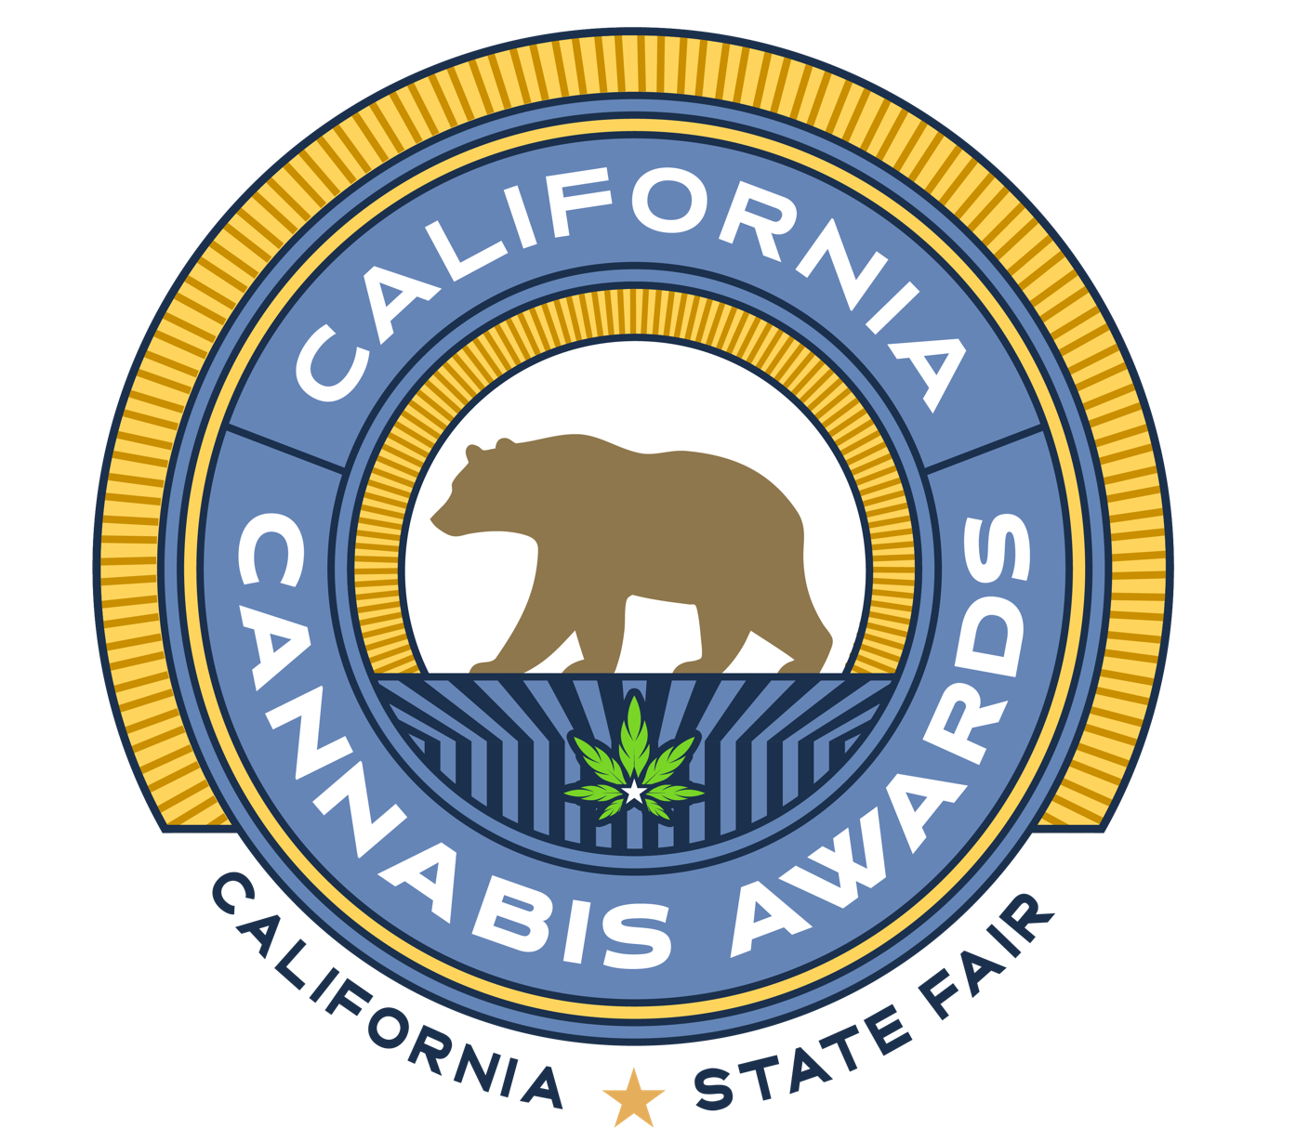

OFFICIAL COMPETITION GUIDE

UPDATED FEBRUARY 2026

Welcome to the 5th Annual California Cannabis Awards!

As we proudly celebrate our 5th Anniversary, we reflect on how far this competition — and California’s cannabis industry — has come. For 172 years, the California State Fair has recognized the excellence of California’s finest agricultural industries. The inclusion of cannabis in the roster of recognized agricultural industries represents a newfound acceptance and celebration of California’s rich legacy of cannabis cultivation and the cannabis growers large and small across the state that produce it. What began as a bold vision to recognize and legitimize excellence has grown into a trusted platform honoring the cultivators, manufacturers, and innovators who continue to raise the bar through craftsmanship, dedication, and an uncompromising commitment to quality.

This year, we are excited to deepen the experience through our continued partnership with Budist, whose distinguished judges bring sensory expertise, cultural perspective, and real-world consumer insight to complement our science-based evaluation. Together, analytical precision and human experience create a more complete and meaningful assessment of quality by SC Labs.

We are also pleased to introduce the Home Grow – Personal Use competition, celebrating the passion, skill, and dedication of California’s individual cultivators. This addition honors the roots of cannabis culture, where innovation and craftsmanship flourish at every level.

Whether you are a returning participant or joining us for the first time, thank you for being part of this journey. The California Cannabis Awards remains grounded in integrity, combining rigorous laboratory testing with thoughtful evaluation to ensure credibility, fairness, and transparency.

Beyond medals and honors, this competition celebrates the artistry, discipline, and progress of an industry that continues to evolve, inspire, and redefine standards of excellence, culminating in the 50,000-square-foot on-site California Cannabis Experience at the Fair.

Compete proudly. Connect deeply. Celebrate boldly.

Thank you for your participation, your trust, and your commitment to quality.

We look forward to celebrating with you.

James Leitz & Dustin Moore
Co-Executive Producers
Fair Play Ventures, LLC

Table of Contents
The California Cannabis Awards at the California State Fair 4
About
Educational Exhibit
Cannabis Sales & Consumption
Sponsorship Opportunities
Competition Highlights 5
Quick Facts
Key Dates
Contact Information
Award Category Overview
Entrance Fees
The Competition Team
Competition Perks 8
Why Enter the Competition
Award Winners Benefits & Support
Competition Details 9
Awards Descriptions
Testing and Evaluation Methods
Entering the Competition
Rules & Regulations 12
Competition Overview
How to Enter
Rules & Regulations 15

The California Cannabis Awards at the California State Fair
About
The 2026 California Cannabis Awards at the California State Fair will be a 5th annual statewide celebration, including an educational exhibit and onsite cannabis sales and consumption. The cannabis exhibit will run the duration of the California State Fair from July 17 through August 2, 2026. Open to all fairgoers (21+).

CA CANNABIS EXPERIENCE

The 50,000 s/f CA Cannabis Experience, curated by Fair Play Ventures, is comprised of educational displays celebrating the agricultural and cultural heritage of California cannabis, as well as the societal impact the plant has had on the State over the decades. The Experience will showcase the Award Winners, sponsors and partners alongside eye-catching creative highlighting the award winners and products. The exhibit is brought to life by booths and activations hosted by cannabis industry brands, associations, and government partners.

Cannabis Sales & Consumption
In 2026, the California Cannabis Awards will build upon a historical first in bringing cannabis sales and consumption to the fairgrounds footprint. The California State Fair continues to lead the nation in showcasing the California cannabis industry, its history, culture and craft farmers through a unique blend of educational exhibits, experiential activations, and commerce.

Award-winning cannabis flower and products will be sold through a centralized sales desk within the CA Cannabis Experience and are allowed for consumption within designated areas.

Sponsorship Opportunities
2026 Sponsorship Opportunities are available with Premier, Official, and Affiliate tier level opportunities for brand positioning and exposure to a diverse, canna-curious audience. Sponsorships provide access to exhibition packages, custom brand activations, product sales, inclusion in publicity campaigns, and placement opportunities throughout the California Cannabis Awards and CA Cannabis Experience at the California State Fair.
For sponsorship related inquiries, please reach out to gina@calcannabisawards.com

Competition Highlights

Quick Facts

The 5th Annual California Cannabis Awards is a first-of-its-kind, state-sanctioned cannabis competition and fairgrounds experience. Celebrating California’s rich agricultural history, cannabis has joined the State Fair roster of coveted annual competitions, alongside wine, cheese, olive oil and craft beer.

The 2026 Awards competition continues to celebrate California’s cannabis industry with an expanded format:
- The competition is open to all licensed California cultivators and brands.
- There are 10 Award Categories
- Awarding 29 Chemotypes and Product Types
- 160+ Gold, Silver, and Bronze Medals
- 10 Golden Bear “Best of California” Trophies issued by the California State Fair
- The Flower Awards format is rooted in quantifiable, science-based criteria with testing certified by a third-party, trusted laboratory testing partner, SC Labs.
- Organizers have partnered with Budist and the Budist Evaluation Method that utilizes a 100-point rating scale to evaluate all Product Categories and determine the Golden Bear winners for all Flower Categories.
- New for 2026! Home Grow Personal Use Flower Competition
- Award winners will be announced in June 2026 and celebrated during the California State Fair, July 17 – August 2, 2026.

Key Dates
February 23, 2026 Submission Window Opens
May 22, 2026 Submission Window Closes
July 1, 2026 Gold, Silver, and Bronze Announcements
July 18, 2026 Golden Bear Awards Celebration
July 25, 2026 Home Grow – Personal Use Awards

Contact Information
Official Website: www.calcannabisawards.com
Official Email: info@calcannabisawards.com

Competition Category Overview
Using both science-based testing and expert judging evaluation components, awards are given across the below cannabis product categories and subcategories, with an overall “Best of California” Golden Bear Trophy for each of the ten categories.

FLOWER CATEGORIES
Each Flower category will use scientific testing to award Gold, Silver, and Bronze medals based on cannabinoid and terpene expression. Cannabinoids awarded include CBDa, CBGa, and Total Cannabinoids. Terpenes awarded include Caryophyllene, Limonene, Myrcene, Ocimene, Pinene, and Terpinolene, as well as Co-Dominant and Total Terpenes. A "Unique” award may be designated for any rare terpenes and/or cannabinoids revealed during testing.
- INDOOR: For cannabis grown in a permanent structure using at least 25 watts of artificial light per square foot
- MIXED-LIGHT: For cannabis grown in a greenhouse, hoophouse, glasshouse, or similar structure
- OUTDOOR: For cannabis grown outside without using any artificial lighting or light deprivation techniques on mature plants
- HOME GROW – PERSONAL USE – (see separate section below)

PRODUCT CATEGORIES
Each Product category will use expert human judging panels to award Gold, Silver, and Bronze medals by product type subcategory.

- BEVERAGES | Ready-to-Drink, Enhancers & Mixers (Combined)
- CARTRIDGES | Solvent – Terpenes Added  Solvent – Live Resin / No Added Terpenes Solventless
- CONCENTRATES | Solvent  Solventless – Hash  Solventless – Rosin
- EDIBLES  - PRE-ROLLS | Baked Goods  Candies  Chocolates  Blunts  Infused – Solvent  Infused – Solventless  Non-Infused
- WELLNESS | Tablets / Capsules  Tinctures  Topicals
Entrance Fees

1st Product or Cultivar | $400
2nd Product or Cultivar | $375
3rd Product or Cultivar | $350
4th + Product or Cultivar | $325

The Competition Team

ORGANIZERS
The California Cannabis Awards is produced in partnership with Cal Expo and Fair Play Ventures, LLC. Fair Play Ventures is an exciting partnership between Cultivar Events, creators and producers of the 2022/2023 competition and exhibit, and Embarc, one of California’s leading cannabis retailers and cannabis event specialists.

PARTNERS
Embarc, Official Retail Partner
The California Cannabis Awards proudly welcomes Embarc as our returning strategic marketing and official retail partner. In 2024, Embarc joined us in making history by bringing onsite cannabis retail sales and consumption to the California State Fair. Embarc operates a fleet of cannabis dispensaries across California and has set the gold-standard for cannabis sales and consumption programs inside other large-scale events like “Grasslands'' inside Outside Lands.
For more information, visit www.goembarc.com

Expert Human Judging, Budist
Budist is the industry’s first social review platform for cannabis products and brands. The Budist community is led by a diverse group of cannabis critics, or “Budists”, which includes certified Ganjiers, cup judges, subject matter experts, and connoisseurs. The Budist Evaluation Method, a 100-point rating scale, will be used to evaluate all Flower Gold Medalists and determine the Golden Bear winners for Sun Grown, Mixed Light and Indoor Categories. Budist will also judge all other Categories and Product Types to determine Gold, Silver, and Bronze medals and Golden Bear winners by Category.
For more information, visit www.budist.com

Trusted Laboratory Partner, SC Labs
The California Cannabis Awards’ flower categories will be scored objectively through science-based analysis performed and certified by SC Labs, one of California’s premier cannabis testing labs. SC Labs will provide all flower entrants with the required Terpene and Cannabinoid testing required and furnish a PhytoFacts® chemometric report that will identify the unique compounds of the submission to determine the Gold, Silver and Bronze medal winners.
For more information, visit www.sclabs.com

Competition Perks
Why Enter the Competition
Beyond the accolades, entering the awards competition is to participate in something greater: the social progress of cannabis, an unparalleled consumer education opportunity, a recognition of the innovation, diversity, and excellence of California’s cannabis community.

Award Winners Benefits & Support
In addition to honoring the esteemed cultivators and manufacturers and the work that goes into producing the best cannabis products California has to offer, award winners will benefit from full-scale publicity, marketing, and retail opportunities.
- Publicity Campaign: A publicity campaign including press releases, media advisories and social content promoting the winners will last from pre-launch through the duration of the fair.
- Marketing Tools: In addition to unique PR and publicity opportunities, winners will be the recipients of official award seal digital assets, along with logo usage rights, to digitally market California State Fair Cannabis Award designation on all award-winning product packaging.
- Medals & Trophies: Winning submissions will receive award-winning designations, represented by product seals (stickers) and medals; Gold, Silver, Bronze, and the coveted Golden Bear trophies for the “Best of California” winners.
- Onsite State Fair Retail Opportunities: All award-winning products will be considered for inclusion of onsite sales at the cannabis dispensary during the California State Fair. Considerations include product and shelf availability, as well as limitations to serving sizes sold at the event.
- Statewide Retail Opportunities: Golden Bear winners will be welcomed into the inventory assortment and sold at select Embarc dispensary locations across California for a limited time, where Golden Bear winners will enjoy featured displays. Please note, this retail opportunity is dependent upon the timely availability and product quantities of the specific Golden Bear-winning product.
- Brand Exposure: Award winners will get the one-of-a-kind brand exposure through media coverage, partnership coverage, physical displays, including an award winner dossier feature wall, seen by thousands of fairgoers, expanded retail opportunities, the industry-attended awards ceremony, and more.
- Forever a Winner: The award represents an evergreen achievement, and all California State Fair Cannabis Award winners will be recorded as historical winners on the official site.
- Fee Waivers: The Best of California Golden Bear winners will receive complimentary entry fee waiver for the 2027 competition.

Competition Details
Awards Description

GOLD, SILVER, AND BRONZE AWARDS
Gold, Silver, and Bronze medals will be awarded across all Flower and Product categories, as listed in Award Category Overview.
For Flower Categories, Gold, Silver, and Bronze medals will be awarded to competition entrants whose submission achieves the top, second, and third highest terpene or cannabinoid expression as indicated by the scientific testing completed by a trusted third-partner scientific testing partner. The terpenes tested for awards include Caryophyllene, Limonene, Myrcene, Ocimene, Pinene, and Terpinolene, as well as additional awards for Co-Dominant and Total Terpenes. Cannabinoid awards include CBDa, CBGa, and Total Cannabinoids.
A “Unique” Gold medal award and designation may be given to an entrant whose product possesses rare terpenes and/or cannabinoids revealed during testing and exist outside the current terpene and cannabinoid awards categories.
Flower product submissions which include terpene additives or other additives will not be considered for evaluation and will be disqualified from the competition.

For Product Categories, Gold, Silver, and Bronze medals will be awarded for each product category using an expert panel of human judges and a proprietary, blind 100-point testing methodology.
GOLDEN BEAR “BEST OF CALIFORNIA” AWARDS
A Golden Bear Award, a coveted and historical prize given by the California State Fair across industries, will be awarded for each Flower and Product award category. In the Flower Categories, all Gold, Silver and Bronze medalists per chemotype will qualify for the subjective judging panel that will determine the Golden Bear winners. For the other Product Categories, only the Gold medalists will be immediately qualified and considered for the Golden Bear designation, determined by an expert human judging process.

Testing and Evaluation Methods

SAFETY AND SCIENCE-FIRST EVALUATION
All entrants must provide a valid Certificate of Analysis (COA) from a California-licensed cannabis testing laboratory to participate.

To maintain parity and uniformity, all Flower Category submissions must be tested by the same laboratory, using the same methods and technology for cannabinoid and terpene testing. The entrance fee for the flower competition includes third-party laboratory testing by SC Labs. SC Labs clients who have obtained their COA and requisite testing will not undergo additional testing as the results of that test will be used for the competition.

SC Labs will test each cultivar for chemometric data and report results using the innovative cannabinoid and terpene reporting platform PhytoFacts. This easy-to-understand report characterizes the chemical profile of cannabis through intuitive data visualizations. These visualizations identify the chemical profile, dominant and proportional cannabinoids and terpenes, sensory attributes, and potential entourage effects of the submitted sample.
PhytoFacts allows for accurate sorting of samples into major chemometric families and subcategories that highlight similar sensory and physiological properties. Each entry will be tested for moisture content, water activity, pesticide residues, microbiological contaminants, heavy metals, as well as mycotoxins, and any entry that exceeds limitations established by the State of California will be disqualified from the competition.

Incentives for SC Labs current and new clients are available including:
- For the Outdoor Flower Category, submissions which obtained their COA and the proper testing from SC Labs between October 1, 2025, and February 22, 2026, may be eligible.
- All other SC Labs client flower submissions are subject to a retroactive January 1 to February 22, 2026, test allowance.

Please contact your SC Labs representative for inquiries related to submitting through the customer service portal and eligibility for use of a retroactive test.

EXPERT HUMAN JUDGING
The California Cannabis Awards has identified specific product categories for rating and evaluation by the Budist community, which includes certified Ganjiers, cup judges, subject matter experts, and connoisseurs.

The Product award categories and Golden Bear evaluations will be powered by Budist. Product samples will be allocated to a panel of cannabis judges, chosen based on qualifications and areas of expertise, for assessment and scoring. Budists will use a 100-point rating system to objectively evaluate each entry based on attributes such as Aroma, Flavor, Appearance and Effect. Each of these attributes are assigned point values based on factors such as complexity, intensity, and efficacy, and the total points are averaged to yield the final rating. Judges are required to follow a standardized methodology to ensure that their ratings are fair, honest, and based on their professional assessment of each entry. This 100-point system is on par with internationally-recognized rating systems used by many specialty goods industries, including wine, beer, chocolate and coffee. This approach will be applied to each Product category to determine Gold, Silver, and Bronze medalists. The gold medalists of each product type within each of the Flower and Product categories will compete for a coveted Golden Bear trophy.

Entering the Competition

REGISTERING
All entrants must register on the Official Competition Registration portal located online at calcannabisawards.com/competition/

The Submission Window will be open from February 23 - May 22, 2026.

The online registration process will require a valid California cannabis license, Metrc Batch Number, and a valid COA from any California-licensed cannabis testing laboratory.

PRODUCT SUBMISSION
10 units of shelf-ready product for each submission are required for entrance into the competition. These samples will be used in the competition for scientific testing components, evaluation by the expert human judging panel, high-resolution photography for marketing purposes, and evaluation for a Golden Bear for all Gold Medal placements.

PRODUCT DROP OFF

Once the online registration portion is complete, all entrants will receive an invoice to complete payment.

Once payment is received, entrants will receive an email with product drop off instructions.

Distributor logistics is powered by Nabis and Redwood Roots with drop off locations in northern and southern California.

Home Grow – Personal Use Competition
Competition Overview – Home Grow Flower

The Home Grow – Flower competition recognizes cannabis flower cultivated by California residents for personal, non-commercial use, honoring quality, consistency, and technical execution at the individual hobbyist grower level.

Home Grow entries are evaluated and awarded Gold, Silver, and Bronze medals within the same chemotype-based sub-categories used for Commercial Flower, ensuring consistency and integrity across the California Cannabis Awards.

Unlike Commercial Flower categories, Home Grow entries are not separated by cultivation method. Sungrown, indoor, and mixed-light submissions compete together within each chemotype category.

All entries are judged using a science-based evaluation process, including comprehensive laboratory testing conducted by SC Labs. Medal placements are determined using objective analytical data derived from laboratory results and PhytoFacts™ chemometric analysis.

Gold Medal winners advance to a live, on-site judging final culminating in the award of the Golden Bear Trophy and the title of “Best Home Grow in California.” The Golden Bear represents the highest honor at the California Cannabis Awards and is the same blue-ribbon trophy awarded across the California State Fair for excellence in agriculture and craft.

Submission Window

The submission window for the Home Grow – Flower category is open from
February 23 through May 22, 2026.

All required entry materials, including the California Cannabis Awards entry form and SC Labs sample submission, must be completed within this timeframe to be eligible for judging.

Entering the Home Grow Competition

To enter the Home Grow category, participants must complete the following steps:

- Complete the California Cannabis Awards Entry Form
Entrants must first complete the official California Cannabis Awards entry form and provide all required information in the designated fields. Entries will not be accepted without a completed form.
- Entry Fee: $250 per sample/entry
Entry fees include laboratory testing, chemometric analysis, and eligibility for medal awards.

- Create an SC Labs Account
After submitting the entry form, entrants must establish an individual account with SC Labs to initiate the testing process. There will be a link to SC Labs in the Registration Portal. For more information and to set up your account, visit www.sclabs.com
- Prepare Your Submission
Each entry must consist of seven (7) grams of cannabis flower, properly sealed and labeled in accordance with SC Labs submission requirements.
- Schedule Sample Pickup
Entrants will schedule a personal pickup with SC Labs for sample collection.
- Laboratory Testing & Analysis
SC Labs will conduct laboratory testing for potency, terpene concentration, and cannabinoid concentration. Each entry will receive a PhytoFacts™ chemometric report, which serves as the basis for competition scoring.
- Judging & Awards
Medals are awarded based exclusively on laboratory results, including:
  - Highest concentration of six (6) specific terpenes; Limonene, myrcene, beta-caryophyllene, pinene, ocimene, terpinolene
  - Co-dominant terpene (MCL)
  - Total terpene concentration
  - Primary cannabinoids CBG and CBD
  - Overall cannabinoid concentration
- “Best of California” – Golden Bear Trophy & Ceremony – July 25

Golden Bear Trophy & Home Grow Finals

All Gold Medal Home Grow winners will be contacted by Event Organizers and invited to participate in a live, on-site judging panel held during the California State Fair.

Gold Medal Home Grow winners will be contacted by organizers to schedule a pick-up for an additional 14 grams of product for the Official Testing and Judging. Please keep your product properly preserved throughout the submission window while we test for the gold, silver and bronze early rounds. You never know, you could be a Gold Medalist and qualify for the Golden Bear Award!

The live judging program and Golden Bear award presentation will take place on
Saturday, July 25.

Each Gold Medal Home Grow entry will be judged by the same panel of expert judges responsible for evaluating and awarding Commercial Cannabis Flower medals and Golden Bear Trophies, ensuring equal standards and full competitive parity.

Following the live judging, one Home Grow finalist will be awarded the Golden Bear Trophy and the title of “Best Home Grow in California.”

Rules & Regulations

Enforcement of Rules & Regulations:

The entry requirements, as printed herein, will be strictly enforced. Any entries found not to comply with the entry requirements will be rejected. Any entry form found to contain untrue information may result in disqualification from all awards and may also bar the entrant from entering the California Cannabis Awards competition in the future.

Advertising
- The California State Fair reserves the right to revoke an award or disqualify an entrant from this and future competitions for any misleading advertising or information connected to the California Cannabis Awards or for violating any of the following rules:
  - Award seals may be affixed only to packaging of State Fair award-winning cannabis products. Only official State Fair award seals are authorized to designate California State Fair award winners.
  - No awards designation representation or labeling will be made that is misleading or deceptive to the trade or the consuming public.
  - No representation will be made that states, implies, or permits the inference that a product is identical to an award winner unless this is the case.

Confidentiality & Privacy Provisions
- By entering the competition, entrants agree that Certificate of Analyses and PhytoFacts report(s) will be shared with Competition Team and the California State Fair.

Disqualifications
  - Any failure of DCC regulations would result in disqualification. This may include but is not limited to contamination issues that involve pesticides (herbicides and fungicides), solvents, heavy metals, microbiological contaminants, mycotoxins, and foreign material.
    - Entrants will be notified of a failed sample. If your batch fails for compliance, an SC Labs representative will hold a call to review and discuss remediation options. Entrants will have the opportunity for remediation, and resubmission before final results are tabulated. No re-submissions will be allowed after May 22, 2026. However, late submissions that have not been tested or failed prior to May 22, 2026 can participate in a Remediation Window from May 22-29, 2026. In the event of disqualification, an entrant must pay for a new COA for re-submission but entry fees for the Awards will be applied to the new sample submitted.
  - Entrants will be disqualified for misrepresentation of award category, including light source.

Entry Limitations

Entrants must be able to provide a valid and current California cultivation or manufacturing license.

There are no limits on the number of individual samples/cultivars that may be submitted.

No entrant will be allowed to submit more than one sample from a particular cultivar from a particular grow unless the samples are from a separate vintage/grow cycle.

Registration / testing payments must be received in order for test results to be released and to be eligible to participate in the competition.

General Rules
- California State Fair General Rules are subject to any action that may cause revision or curtailment at any time before each competition or judging. Upon submission of online entry and signature on detailed receipt if applicable, the exhibitor acknowledges that they have read and understood these rules and all others of the competition in which they enter and are further responsible for viewing, reading and understanding all revisions or curtailments on the State Fair’s website before the competition. Exhibitors may request an additional copy of the most current rules by contacting the entry office:
email: entryoffice@calexpo.com.
- Awards Organizers may require that any cannabis receiving an award be reviewed and qualified by representatives of the Organizing Committee who shall verify that all entry requirements have been met.
- The testing standards of the competition written herein are subject to change as the State of California’s cannabis testing and/or pesticide regulations evolve.
- Award Organizers reserve the right to combine award sub-categories.
- No entrant or representative may disparage awards of other cannabis entrants to the trade or public.
- Flower award categories are not determined by cultivation license size type or mixed light tier license status.

Award seals may be affixed only to packaging of State Fair award-winning cannabis cultivars. Only official State Fair award seals are authorized to designate California State Fair award winners.

